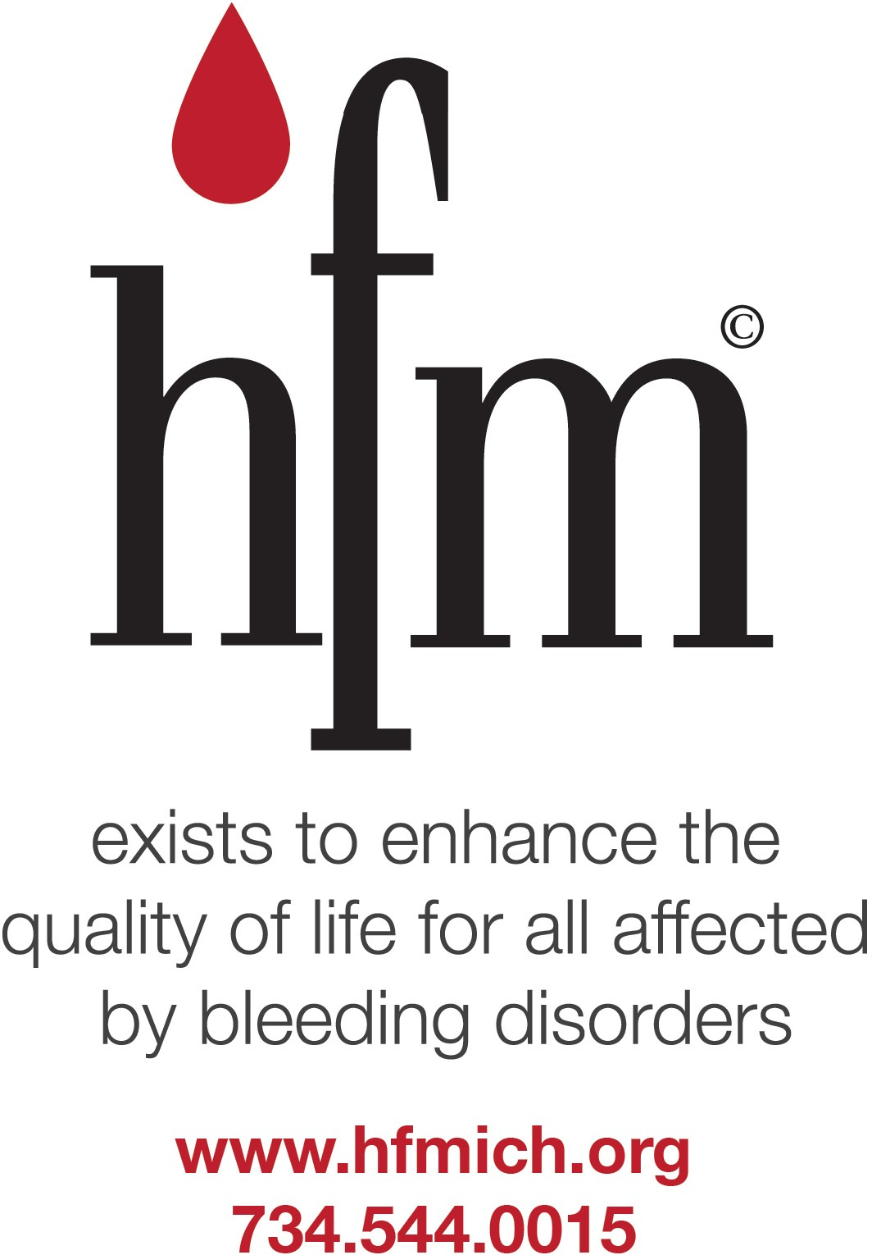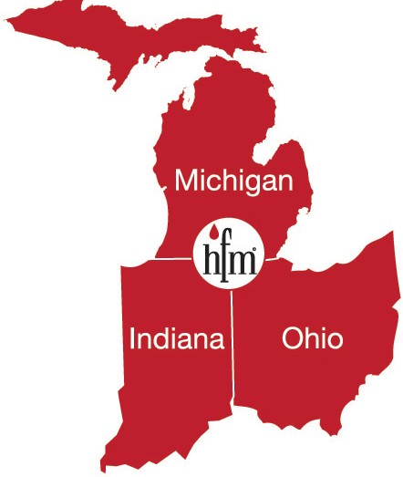
MICHIGAN HEMOPHILIA TREATMENT CENTERS

PEDIATRICS
Children’s Hospital of Michigan  Hemostasis and Thrombosis Center | 3901 Beaubien Blvd., 3rd Carl’s Building  Detroit, MI 48201 | Phone: 313-745-8432  After Hours: 313-745-5111 pager #5307
Helen DeVos Children’s Hospital  Coagulation Disorders Program | 100 Michigan Street NE  Grand Rapids, MI 49503 | Phone: 616-391-2033  After Hours: 616-391-1774 ask for hematologist on call
PEDIATRICS AND ADULTS
Bronson Hemophilia Treatment Center | 805 John St.  Kalamazoo, MI 49001 | Phone: 269-286-7180  Pediatric After hours269-341-6350  Adult after hours269-286-7170
Cascade Hemophilia Consortium | 2025 Traverwood, Suite A  Ann Arbor, MI 48105 | Phone: 734-996-3300
Hurley Medical Center  Eastern MI Hemophilia Treatment Center | One Hurley Plaza  Flint, MI 48503 | Phone: 800-257-9432  Pediatrics After Hours: 810-257-9000  Adult After Hours: 810-762-8200
Michigan State University  Center for Bleeding and Clotting Disorders | 1355 Bogue St. 220 Life Sciences  East Lansing, MI 48824 | Phone: 517-353-9385  Pediatric After Hours: 517-371-8448  Adult After Hours: 517-342-6413
Munson Medical Center  Northern Regional Bleeding Disorders Center | 1105 Sixth  Traverse City, MI 49684 | Phone: 231-935-7227  Pediatric After Hours: 800-468-6766  Adult After Hours: 231-935-5000
University of Michigan  Hemophilia and Coagulation Disorders | F2480 Mott Hospital Box 0235 1500 E. Medical Center Dr.  Ann Arbor, MI 48109-0235 | Phone: 734-647-8902 Option 1  After Hours: 734-936-6267
ADULTS
Henry Ford Hospital  Adult Hemophilia and Thrombosis Center | 2800 W. Grand Blvd., Ste. 3E-204  Detroit, MI 48202 | Phone: 313-916-3790  After Hours: 313-916-2600  *Ask for the Hematologist on-call
Detroit Receiving Hospital Comprehensive Center for Bleeding Disorders and Thrombosis | 4201 St. Antoine 7B UHC  Detroit, MI 48201 | Phone: 313-745-7690  After Hours: 313-745-5111

